
- CALL TO MEET -

Hosted by OAA
Sunday, June 17, 2018

Host Club and Venue | OAA  1420 Bayly Street, Unit # 17  Pickering ON, L1W 3R4  info@OAAgym.ca  OAAgym.ca  Please note; Club administrators and coaches may contact the Meet Director(s) with any questions. Athletes and parents should direct questions to their own club staff. The host club will not respond to communications from athletes and parents.
GO LIASON | Allison Tanaka  Gymnastics Ontario  Tel: (647) 344-5149  Fax: (647) 344-4816  tnt@gymnasticsontario.ca  www.gymnasticsontario.ca
OrganizING COMMITTEE  Lead | Cameron Osborne  (905) 999-2479  info@OAAgym.ca
LOCATION | Pickering, Ontario
Date | Sunday, June 17, 2018
PRESENTATION THE CITY OF pickering | For information on the City of Pickering, please visit: www.pickering.ca  (Pickering waterfront and Pickering Town Centre seen below)  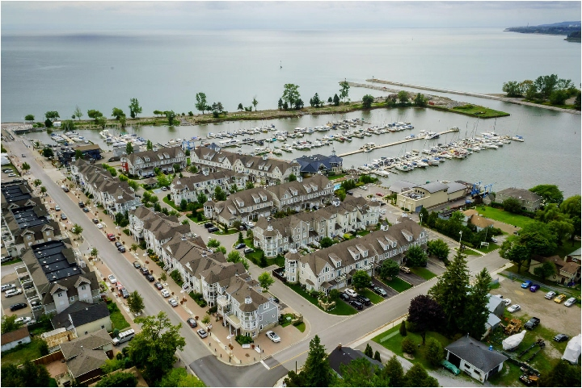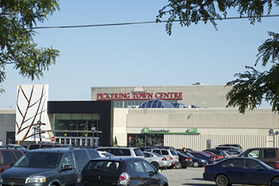
Venue | OAA/Ultimate Canadian Athletics  1420 Bayly Street, Unit # 17  Pickering ON, L1W 3R4  (most northern unit of 1420 bayly)
Directions
  The venue is located just south of the 401 on Bayly St.  If driving west: take the Liverpool Road exit, turn left (south) on Liverpool Road and left (east) on Bayly Street.  If driving east: take the Whites Road exit, turn right (south) on Whites Road and left (east) on Bayly Street.  Unit 17 is the far north unit at 1420.  This venue is very accessible if taking the GO train. Follow the fence line just east of the train tracks; it opens behind 1420 Bayly Street. | 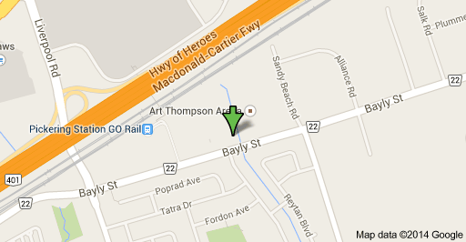
eligible Athletes | Individual Trampoline: Showcase, Interclub A to D, Masters Beginner to Elite, Provincial 1 to 4 and National 5 and 6.  Synchronized Trampoline: Interclub/Masters Beginner & Advanced, Provincial 1 to 4 and National 5.  Double-Mini Trampoline: Showcase, Interclub A to C, Masters Beginner to Elite, Provincial 1 to 4 and National 5 and 6.  Tumbling: Showcase, Interclub A to C, Masters Beginner to Elite, Provincial 1 and 2
ENTRY Fees | Initial Registration Fee  Additional Event Registration Fee | $50.00  $25.00 for Each additional event
ENTRY Fees | Please forward one club cheque, E-transfer or Visa/MasterCard authorization to the host club accompanied with a completed registration form. All clubs must fill out their registration forms electronically. The Excel file has been forwarded to all clubs with the ‘Call to Meet’ that clubs are required to complete and e-mail to the host club prior to the registration deadline.  The Excel registration form and payment must be received by the host club on Thursday, May 17, 2018. Post-dated cheques will NOT be accepted and will be considered as a late payment. No refunds except with medical petition.
registration deadline | Thursday, May 17, 2018
late fees | $25.00 per athlete for all registrations received after Thursday, May 17, 2018. Late fee must be paid in full by cash or certified cheque prior to the competition or the athlete(s) will not be permitted to compete.  Late fees will be applied to clubs who do not submit a fully completed excel registration form, in addition to full payment, by the registration deadline to the host club.
E-MAIL REGISTRATION TO | info@OAAgym.ca AND tnt@gymnasticsontario.ca
PAYment information | Please remit a club cheque to; E-Transfers can be sent to:  OAA, Attention: Cameron info@OAAgym.ca  1420 Bayly Street, Unit #17  Pickering, ON Credit Card information should be included L1W 3R4 in the registration form
EQUIPMENT | Trampolines: There will be two Eurotramp frame trampolines with rebound parts. The other two are Rebound Stedfast complete. Trampolines are all above the ground with surrounding SA sport matting. Please note the clear height of the building is 22.5 feet  Double-Mini: The double mini is a EuroTramp modified (by Rebound products) frame, with a Rebound string bed, mixture of EuroTramp and Rebound springs. Landing zone will be a SA Sport landing system. Double Mini will be on a 2-foot stage  Tumbling: The tumbling strip has ROSS rod sections, SA sport trocellan carpet rolls with FIG markings into a level resi-pit. Please note the length of the tumbling strip is only 72 feet. Entire tumbling strip is on a 2-foot stage
MEDICAL | First Response Medical Staff on-site. Participant Consent and Medical Data Record forms for all participating gymnasts must be in their possession at the competition.  Gymnastics Ontario sanctioned events are NOT guaranteed to be Peanut/Tree Nut Free events. Attendees are asked not to bring peanuts, peanut products, or products containing traces of peanuts or tree nuts into the gymnasiums/venue and/or change rooms where participants are present. Host clubs have been asked to refrain from serving/selling items with peanuts, peanut products, or products containing traces of peanuts or tree nuts at this event. Gymnastics Ontario asks for your assistance in supporting an inclusive environment for all participants.
COACH REQUIREMENTS | All on-site coaches MUST bring their ‘Coach ID Tag’, provided by Gymnastics Ontario, to the competition.  All coaches must be Gymnastics Ontario members with a minimum of NCCP Level Two Fully Certified ‘Gymnastics’ or ‘Trampoline’. Coaches with athletes level 4 or higher must have their NCCP Level 3 Technical Trampoline. All coaches must be listed on the attached registration form.  In case of a lost, stolen or forgotten ID, coaches will be required to sign form number CP001 stating a minimum level 2 certification for verification. The host club registration desk will have this form available. For replacement Ids contact Danielle at education@gymnasticsontario.ca to discuss options of acquiring a replacement ID or an exemption.  There will be food provided for all Coaches. Please list any dietary concerns via email which, we will do our best to accommodate.
ACCOMMODATION | To SECURE GROUP RATES, the group name for all four hotels is: ‘Trampoline and Tumbling,’ which will be secured until May 17, 2018.  Comfort Inn Pickering  533 Kingston Road  Pickering, ON  905-831-6200  Residence Inn by Marriott Whitby  160 Consumers Drive  Whitby, ON  905-444-9756
ADMISSIONS
  Interclub Year End Event Spectator Admission Prices
  Adult (18 years of age and older) | $8.00
  Youth (11 to 17 years of age) | $5.00
  Senior (55 years of age and older) | $5.00
  Children (6 – 10 years of age) | $3.00
  Child (5 years of age or younger) | Free
  All Athletes competing in the competition are not required to pay an admission fee throughout the weekend.
Vendor Information and Concessions | Saucy's World will be joining us for anyone interested in purchasing gymnastics leotards. FitsUWell Boutique will have trampoline slippers available for purchase and Fine Designs will be running a custom event apparel boutique. Canadian Adventure Camp and Matthews Marketing will be showing us their support, as well as the return of our Photo Booth and event SnapChat filter. Concessions will be available for purchase both with BBQ food outside and food and drinks inside the venue.  

